Assistant Park Manager
Permanent, Full Time

Who we are

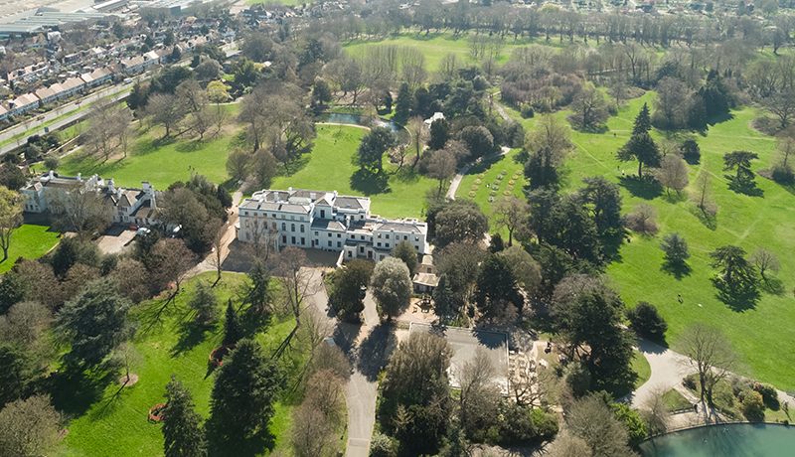
Our 186 acres of Grade II* listed parkland has been awarded Green Flag and London In Bloom Gold and holds an abundance of riches with wild flower meadows, heritage parkland, ornate lakes, interactive playgrounds for families and habitats for a huge range of species.

Gunnersbury Park & Museum launched onto London’s cultural scene in 2018 as the destination in West London for outdoor music concerts and cinema… but that’s not even half our story.

We could also tell you about our local history museum winning NPO status, our 21 listed buildings and structures, our education and community programmes, our brand-new sports facilities, or even our exciting events programme.

There’s so much to be excited about at Gunnersbury and a real opportunity to help shape its future by joining our team.

Role Description
As Assistant Park Manager you’ll be a dedicated park champion. You’ll assist the Park Manager in ensuring that our parkland and infrastructure are maintained to the highest standards, working with external contractors and the rest of the gardening team. Sustainability and ecologically sound will be your new buzz words! We want Gunnersbury to be a safe and welcoming environment for all staff and visitors and you’ll play a crucial role in delivering this. There is real variety to this role and an opportunity to work across all areas of the park.

How to apply
To apply for the role of Assistant Park Manager please send your CV and a cover letter outlining how you meet the requirements of the role to recruitment@visitgunnersbury.org (mark your email as: ‘Assistant Park Manager’ and include your full name in the email header)

Overview

Job Title: | Assistant Park Manager
Reports to: | Park Manager
Responsible for: | Gardening team, volunteers, contractors
Hours: | 37.5 hours/week, covering 5 days out of 7, some evenings and weekends depending on business need
Annual Salary: | £30,000 + benefits package
Location: | Gunnersbury Park (the role is site-based)

Main duties and activities

Park Management & Maintenance

To assist the Park manager in the management of the heritage gardening team and park volunteers, managing their day-to-day work

Under the direction of the Park Manager, carry out regular inspections and surveys to monitor maintenance work and identify and specify repairs. This includes, but is not limited to:

Grounds maintenance work

Playgrounds and play equipment

Lake and pond water quality and weed monitoring

Tree surveys

Park quality inspections
- To assist the Park Manager with park maintenance, repairs and facilities issues including park infrastructure and listed features within the Gunnersbury Park Estate
- To work with the Park Manager to seek sustainable solutions to maintenance issues to minimise adverse environmental impact

Under the direction of the Park Manager, liaise with external contractors as necessary with regard to specialist works (e.g. arboricultural works), planned preventative maintenance and regular cyclical tests (e.g. water testing, emergency lighting)

To ensure that all regulatory certificates and records are up to date and retained on site for inspection

To assist the Park Manager with the management of the grounds maintenance contract to ensure value for money, H&S compliance and Service Level Agreements are being adhered to

To actively monitor the condition of the buildings and park infrastructure, reporting any repair or maintenance issues to the Park Manager and maintenance team

To assist the Park Manager with reading the main and sub-water meters and relevant electricity meters periodically, providing the readings to Finance

To work with the team to periodically review and upgrade the park conservation management plan

To work with the team to put together the Green Flag and London in Bloom submissions

To assist the Park Manager with managing requests for memorial benches, trees and plaques

Health & Safety
- To assist the Park Manager with Health & Safety management of the park by undertaking regular audits of the parkland and infrastructure, identifying hazards and taking corrective action
- To assist the Park Manager with ensuring Risk Assessments, Method Statements and safe working practices and paperwork are up to date and in place for all areas
- To keep up to date records of accidents, incidents and near misses; investigate causes and carry out corrective action in consultation with the Park Manager
- To ensure all staff and volunteers are trained in health and safety appropriate to the task/s they are performing
- To ensure all contractors attending the site have completed the Safety Induction before commencing work and are adequately monitored whilst on site
- As directed by the Park Manager, ensure fire drills of the gardening team building occur at least biannually

Environment & Sustainability
- To work with the Park Manager to support and guide the in-house gardening team and external specialists in the design, planning and management of sensitive planting and landscape design schemes in accordance with the conservation management plan (CMP)

To assist the Park Manager in the implementation of an effective tree safety and arboriculture management regime for the park to ensure the safety of visitors and employees, enhance the biodiversity of the park and promote visitor enjoyment

To work with the Park Manager on sustainable resource management, mitigation of risks relating to climate change and measures to promote environmental resilience

Park Events

To work with our event contractors and event organisers to support and facilitate the smooth running of events in the park and ensure minimal negative impact on the park

To attend meetings, monitor and inspect park areas pre-event and post-event and work to resolve issues

Security

To ensure the security of the park ensuring areas are secured and alarmed as necessary

To ensure that all keys are retained after staff/contractors have left and security codes of locks are periodically changed

Financial

To adhere to the Financial Regulations as directed by the finance team

To assist the Park Manager in managing the park budget ensuring value for money through alternative quotes

To raise purchase orders, check deliveries against delivery notes and obtain invoices and credit notes for the finance team

Other
- To be the lead person for the park when the Park Manager is absent
- To attend meetings and training courses as necessary

To manage the work of the park team and provide support with their personal development

To supervise the duties of volunteers as necessary

To respond to out of hours emergencies, including attending the site and resourcing staff and contractors as required

To be flexible with working hours, including some evenings and weekends

To undertake other duties as may be requested from time to time and commensurate with the responsibility level of the post

Person specification

Skills/qualities/experiences | Essential | Desirable
Passion for and knowledge of horticulture / management of green spaces with appropriate qualifications (HND, ND/NVQ 3 or RHS Level 2/3) | *
Experience and training in ATV with trailer use, or the willingness to train to acquire skills | *
Qualified in use of pesticides and chainsaw use (PA1 & PA6 and CS30 & CS31) |  | *
Knowledge of park and gardens management and maintenance, ideally including management of water features, trees, park infrastructure and nature areas | *
IOSH Managing Safely H&S qualification or the willingness to train to achieve | *
Excellent working knowledge of H&S and able to carry out risk assessments | *
Experience of undertaking surveys, audits and producing reports |  | *
Experience of managing external contractors and Service Level Agreements in contracts |  | *
Good IT skills and proficient user of Microsoft Office | *
Ability to manage a budget effectively | *
Highly organised and flexible, with the ability to manage competing priorities | *
Experience of effectively leading diverse teams | *
Creative and pragmatic problem solver | *
Excellent interpersonal communication skills and confident dealing with people at all levels | *
Physically fit to carry out practical requirements of the job | *
Able to work some evenings and weekends | *
Experience of working within an historic / heritage or conservation environment |  | *

For more information about us please visit our website: https://www.visitgunnersbury.org

