

**Learning Assistant**

**Permanent, Part Time**

**Who we are**

Gunnersbury Park Museum conserves, manages and develops Gunnersbury Estate as a sustainable, recreational, cultural, and educational resource for the benefit of, and in partnership with, all our local communities. Our popular and Sandford award-winning formal learning service welcomes many different groups daily with over 17,000 learners engaged annually. A sense of what we do can be seen on our website:

<https://www.visitgunnersbury.org/learning/>

This exciting educational programme brings to life the site’s heritage and museum collections. We also offer outdoor learning activities within the 186 acres of Grade II* listed parkland, which has been awarded Green Flag and London in Bloom Gold, and includes a host of natural habitats for wildlife as well as many other interesting features and facilities to explore.

We aim to foster deep connections with our diverse communities, heritage and histories. As part of our innovative work with our local communities in April 2023 we were awarded Arts Council England NPO status.

Can you help us to proudly serve our vibrant and diverse community?

It is an exciting time to join the Gunnersbury team.

Benefits of joining include:    
As a Gunnersbury team member, you have access to a range of benefits, including:

✅ **25 days holiday** plus bank holidays

✅ **Hybrid and flexible working options**

✅ **5% company pension contribution** (employees contribute **3%**, totalling **8%**)

✅ **Seasonal organic vegetables** from the community garden

✅ **20% discount** at the Museum Gift Shop (**30%** at Christmas)

✅ **20% discount** at the Leisure Centre

✅ **20% discount** at Pure in the Park Cafe

**✅ Subscription to Arts Professional** – Stay informed and connected with the latest industry insights, expert opinions, funding opportunities, and professional development resources tailored to the arts and culture sector. Once you’re enrolled as an employee, Mariia will add you to the subscription, and you’ll receive an email from Arts Professional with instructions to set up your login.

Your subscription gives you access to:

* The latest arts and culture news
* Expert opinions and in-depth industry analysis
* Funding opportunities and sector reports
* Professional development resources

✅ **Simply Health membership** – fully covered for salaried staff, offering reimbursements for: dental care, diagnostic tests, eye care among other things.

✅ Occasionally offered **tickets to festivals** in the park

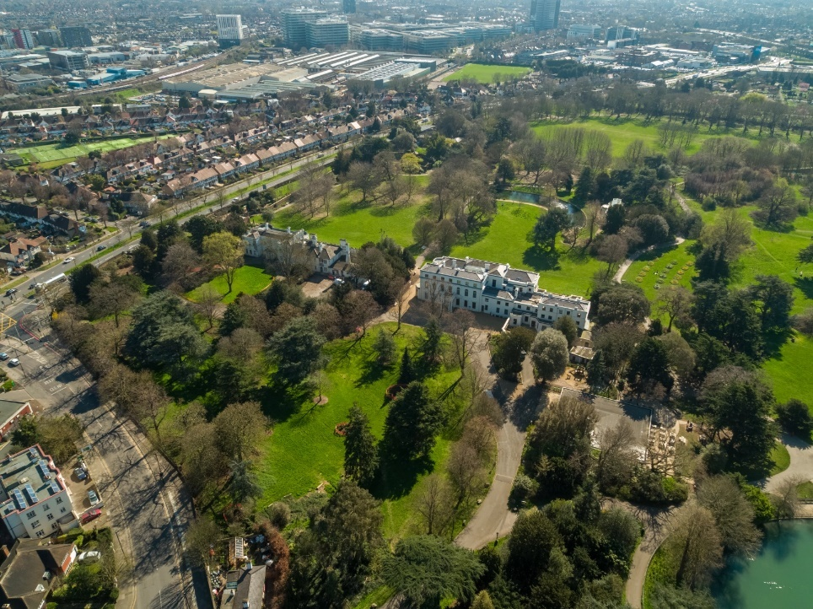

**Role description and purpose:**

This role offers a wonderful opportunity to work in a busy and thriving service. As a Learning Assistant, you’ll be a member of a close and supportive team that is known for delivering excellence in immersive learning experiences in a heritage setting. In addition, you’ll contribute to ensuring a safe, friendly and accessible environment for all learners.

The main purpose of this role is to help deliver Gunnersbury’s Formal Learning Programme to schools and colleges. In doing so, you’ll support our plans and targets and help us achieve the values and goals of the Trust.

**Overview**

**Job Title:** Learning Assistant (permanent and part time)

**Hours:** 4 days a week, 9am – 4pm, with exact days to be arranged. The days will occur within a 34-week time-frame that will be during local school term times only. There is the potential of being offered additional work supporting our other programmes during school holidays.

**Requirement:** This position will require a DBS check that will reveal any unspent convictions. A criminal record may not necessarily be a bar to appointment, as any decision will be treated on its merits and individual circumstances subject to the museum’s overriding obligations to protect the children and vulnerable adults in its charge, members of the public, the safety of the museum’s staff and the collection.

**Location:** Gunnersbury Park Museum (and will involve some travel to schools for outreach delivery of workshops.)

**Salary:** £15.72 per hour

**Responsible to:** Formal Learning Manager

**Main duties and activities**

* Contribute to the successful and safe delivery of Formal Learning programmes to a high standard.
* Deliver a range of indoor and outdoor learning workshops and tours to a variety of formal learners and others engaging with the museum and park.
* Set-up and take down resources for workshops, programmes and events, including some manual handling such as moving costumes, props, tables and seating.
* Ensure all resources used are kept clean and safe, handled carefully, properly stored and any maintenance issues are reported in the correct and timely manner.
* Assist carrying out evaluation, and consultation effectively as required.
* Assist with some general administration tasks as required, such as data inputting for school booking confirmation letters.
* Maintain and enhance requisite levels and types of knowledge and skills to carry out existing and new learning programmes.
* Contribute to any content that is requested for digital engagement purposes.
* Assist and deliver other learning projects, outreach workshops and wider public events as required.
* Work closely and supportively with other members of the Formal Learning team to deliver programming.
* Liaise with other departments, teams and groups as required.
* Understanding of and commitment to the organisation’s equal opportunities policy and applying an equalities approach in the delivery of activities and programmes.
* Understanding of and commitment to the organisation’s values and overall approach to equality, inclusion and diversity.
* Adhere to all policies and procedures of Gunnersbury Museum & Park Development Trust, including those covering access, equalities, safeguarding, customer care and Health and Safety.
* Any other broadly analogous duties which may be allocated from time to time.

*This job description is non-contractual and provided for guidance. It will be updated and amended from time to time in accordance with the changing needs of the organisation and the requirements of the job.*

**Person specification**

**Requirements**

Candidates/post holders will be expected to demonstrate the following:

**Essential = E**

**Desirable = D**

**Knowledge, Skills & Abilities:**

* Good verbal and written communication skills, and an understanding of how communication methods may vary according to the differing ages, backgrounds and abilities of Gunnersbury’s audiences. **E**
* Good time-keeping and time-management skills. **E**
* Adaptable to change and responsive to feedback **E**
* Skills in using dramatic presentation and delivering workshops as a costumed character, interpreting themes appropriately and effectively for a variety of audiences. **E**
* Ability to learn sessions quickly, including learning scripts which may contain language from various historical periods. **E**
* An interest in and enthusiasm for history and/or natural history and the environment. **E**
* An awareness of the National Curriculum and its requirements. **E**
* Good customer service skills and an understanding of the varying needs of different visitors. **E**
* Ability to work effectively and co-operatively as part of a team, and also without supervision as required. **E**
* An awareness of health and safety requirements relevant to working with the public, including vulnerable groups. **E**
* An understanding of the safe handling and use of museum collections and safe working practices in historic buildings. **D**
* Knowledge of and skills in contributing content for social media **D**
* A demonstrable commitment to best practice of access, inclusion and diversity in desirable. **D**

**Experience:**

* Experience of delivering workshops and/or other learning activities in a museum, heritage and/or park setting. **E**
* Experience of working with a variety of learners, such as children, infants, young people, community groups, adults and groups with additional needs. **E**

**How to apply**

Please email the Formal Learning Manager, Gareth Brettell, at [brettellg@visitgunnersbury.org](mailto:brettellg@visitgunnersbury.org) with your CV and a covering letter which outlines why you want the role and describes how your experience meets the person specification . If offered the role, you will need to provide details for two references, at least one of whom should ideally be the most recent employer or education/training provider. The closing date for applications to this role is 9am on Friday 2nd May 2025 with interviews expected to be on 12th or 13th May and applications received after this will not be considered (Please mark your email as: ‘Learning Assistant application’ and include your name in the email header)